Acceptance Criteria test

|  |  |  |  |  |  |  |  |
| --- | --- | --- | --- | --- | --- | --- | --- |
| **Project** | **Key** | **Summary** | **Issue Type** | **Priority** | **Description** | **Acceptance Criteria** | **Story Points** |
| IFB299 032 | [THRTWO-1](https://sefteach01.qut.edu.au/jira/browse/THRTWO-1) | List Book | Story | Must Have | As a Lender,  I want to List a book,  So that Other people may borrow it. | Add new book listing to the website. New book is added to the database. Remove existing book listing. | 8 |
| IFB299 032 | [THRTWO-2](https://sefteach01.qut.edu.au/jira/browse/THRTWO-2) | Contact Lender | Story | Must Have | As a Borrower,  I want to Contact a Lender,  So that I can borrow their book. | ‘Contact’ button contains the correct Mail To link. | 1 |
| IFB299 032 | [THRTWO-3](https://sefteach01.qut.edu.au/jira/browse/THRTWO-3) | Contact Borrower | Story | Must Have | As a Lender,  I want to Contact a Borrower,  So that we can exchange information to facilitate lending of a book. | ‘Contact’ button contains the correct Mail To link. | 1 |
| IFB299 032 | [THRTWO-6](https://sefteach01.qut.edu.au/jira/browse/THRTWO-6) | Title Search | Story | Must Have | As a Borrower,  I want search for books by their Title,  So that I can find books that I might need. | Search returns books when searching for Titles. | 4 |

For our first release all these user stories were prioritised as a must have in our project, this document will test each user story and see if they all meet their acceptance criteria.

1. **List Book**

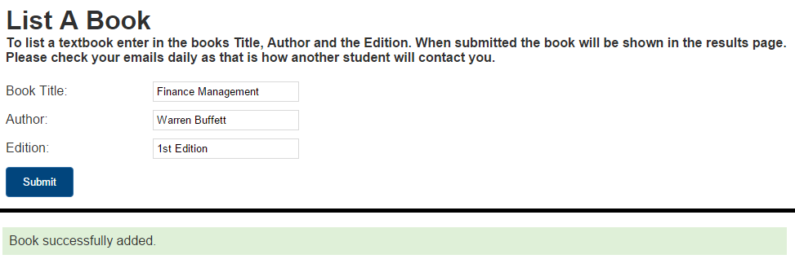

From this screenshot it clearly shows me being able to enter the details of my book that wants to be put into the database, once I hit the submit button you can see the green text that the book has been successfully added to the database.

1. **Contact Lender**

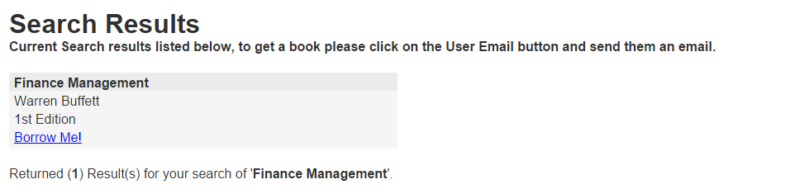When I search for a certain book it shows all the details and gives me a link (Borrow Me!) that forwards their email address so I can get in touch with them.

1. **Contact Borrower**

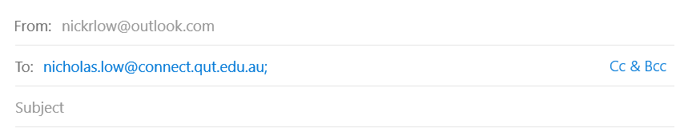

With the before user story in place, the borrower has already contacted the lender by email so they have a direct communication line between both borrower and lender.

1. **Title Search**



Once I search for a book the database shows all the textbooks that match my search, a textbook was listed as ‘finance management’ and I typed it in the search bar and it returned with a result.

As seen in the examples above, each user story is able to meet their acceptance criteria.